**FACULTY OF ENGINEERING AND TECHNOLOGY**

**SCHOOL OF COMPUTING**

**DEPARTMENT OF COMPUTING TECHNOLOGIES**

**AY 2023- 24 EVEN**

**18CSE352T NEURO-FUZZY AND GENETIC PROGRAMMING**

**Simple Interactive Learning Demo on Topic**

**Topic Choice: History of ANN**



**TEAM MEMBERS**

1. RA2111003010549 – KARELLA SURYA VARDHAN
2. RA2111003010548 – CHETHAN C
3. RA2111003010524 – REDDY NEERAJ.R

**Objective:** To explain about various ANN models right from 1940’s to till date using interactive maps.

**Software Used:** Google My Maps

**Screen Shots:** 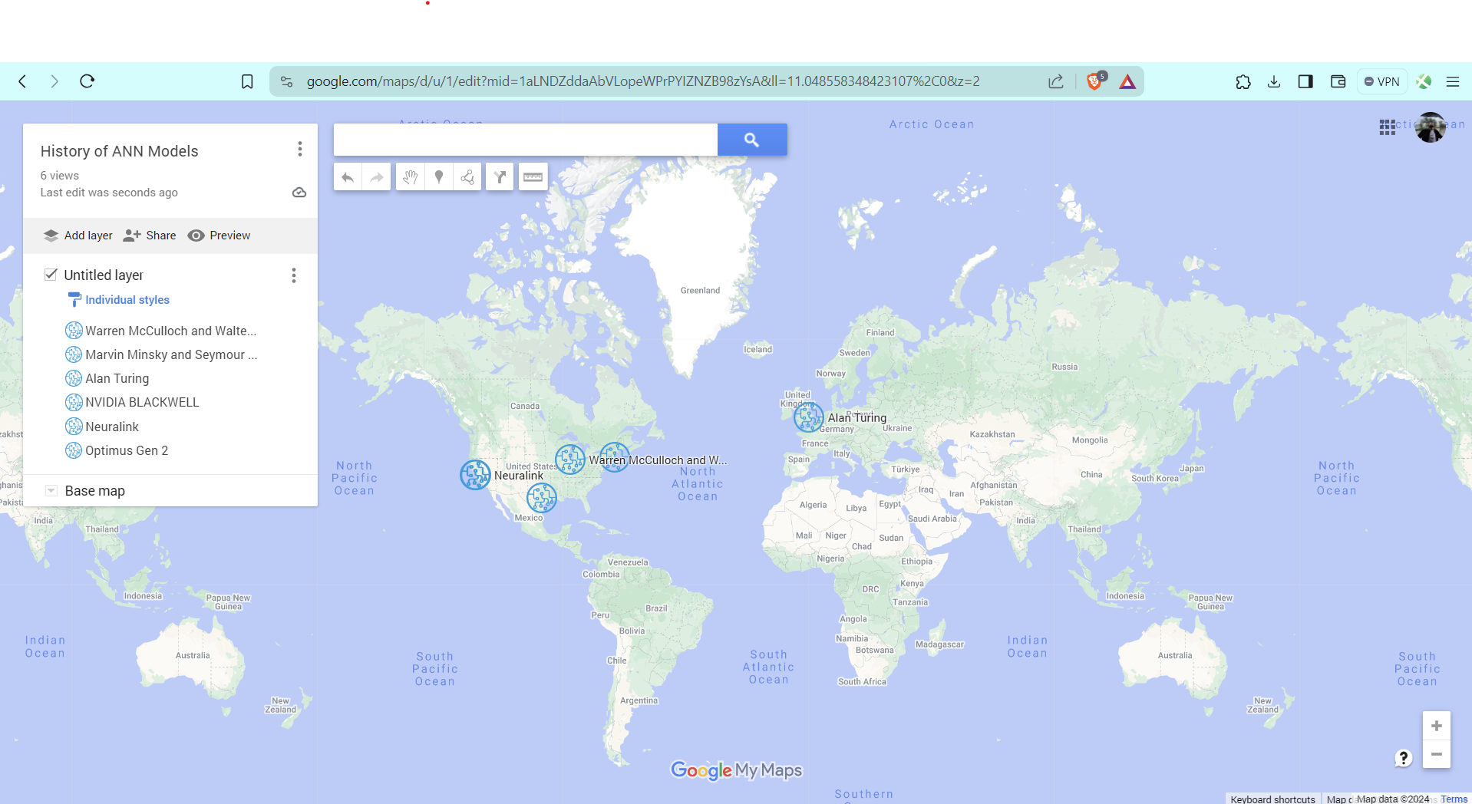

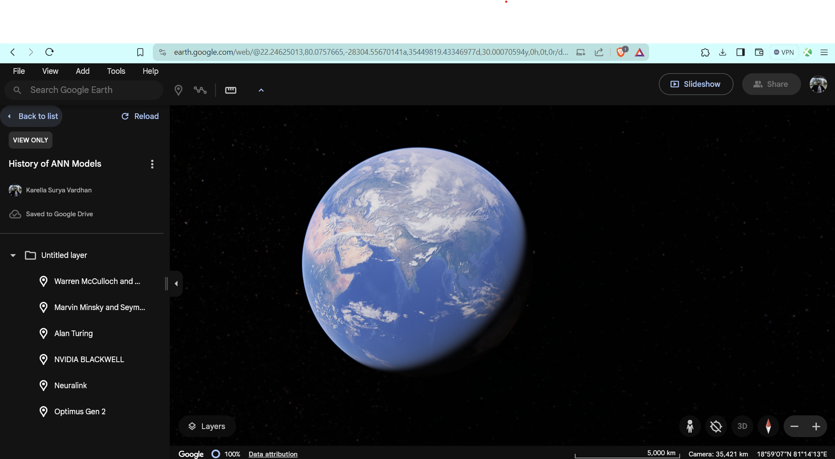

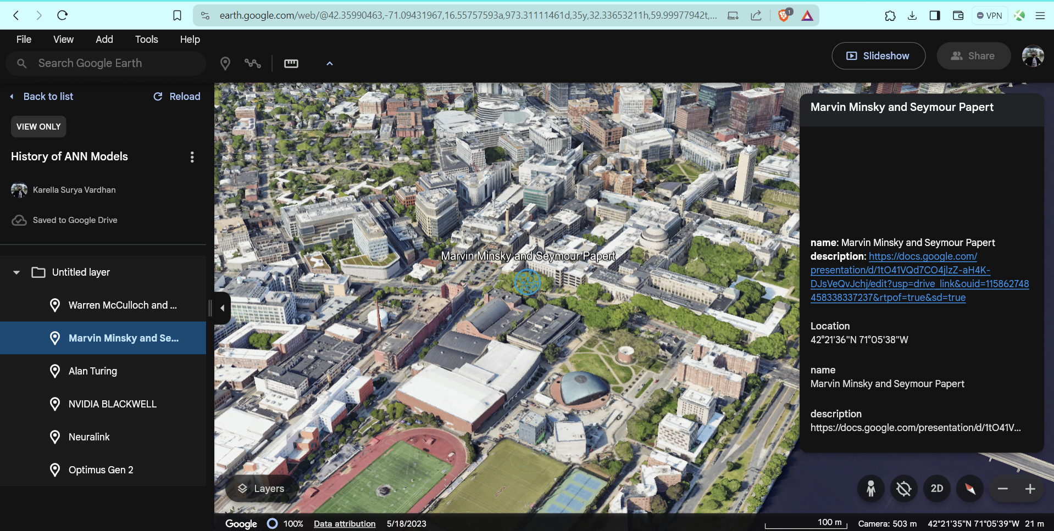

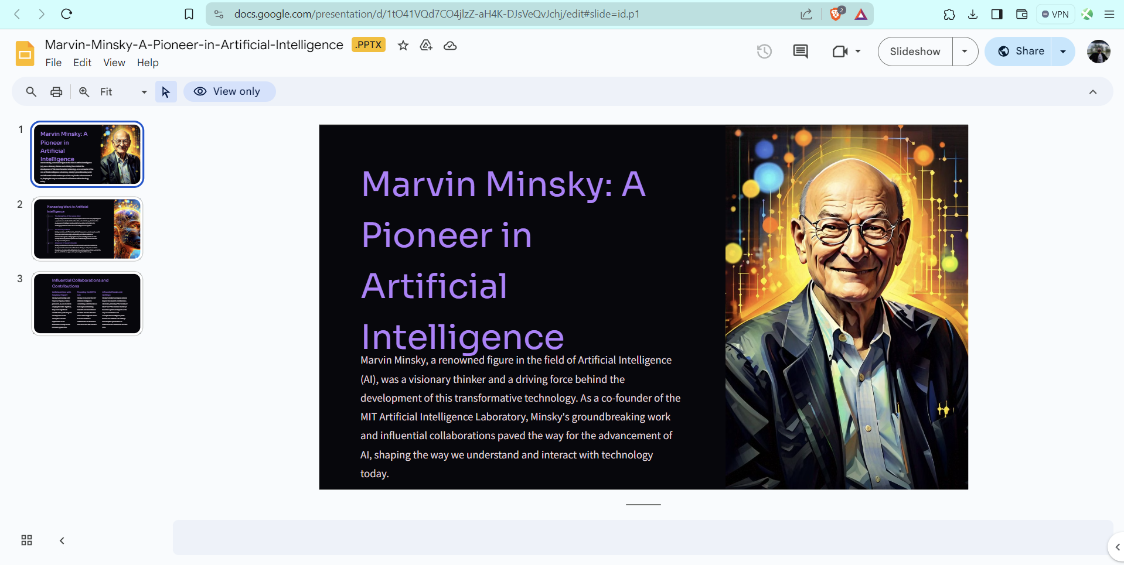

**Video Link (Make it Public):** <https://drive.google.com/file/d/1LekEHBDsQFfFDhFlckkteY5PChFzdvED/view?usp=sharing>

**GitHub Link (Make it Public):**

<https://github.com/KillerVardhan8/Neuro-Fuzzy-Interactive-Tool.git>

**Contribution of Each Members:**

**RA2111003010549:** Explored about the interactive tool and worked on that tool.

**RA2111003010524:** Provided the topics and created the ppts.

**RA2111003010549:** Provided the matter and worked together with 524 for ppts.